JOBSHEET 5 BASIS DATA

MODELING ERD



Disusun Oleh :

Moch Faisal R. (15)

PRODI DIII MANAJEMEN INFORMATIKA

JURUSAN TEKNOLOGI INFORMASI

POLITEKNIK NEGERI MALANG

TAHUN 2019

Praktikum 1

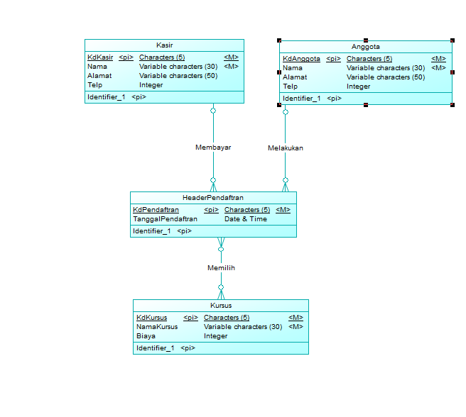

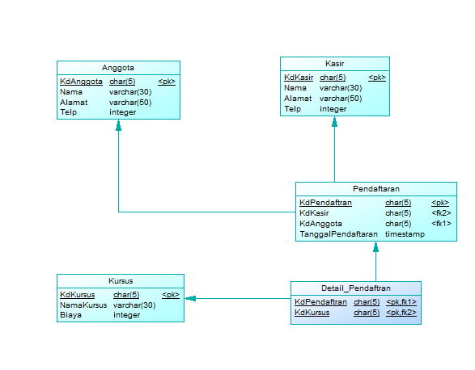

Tugas 1

CDM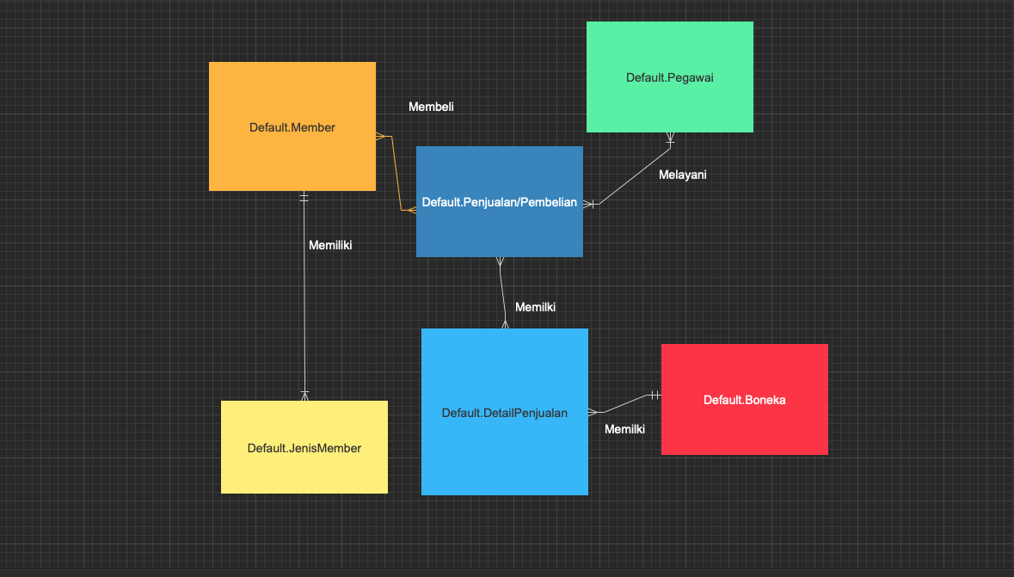

PDM

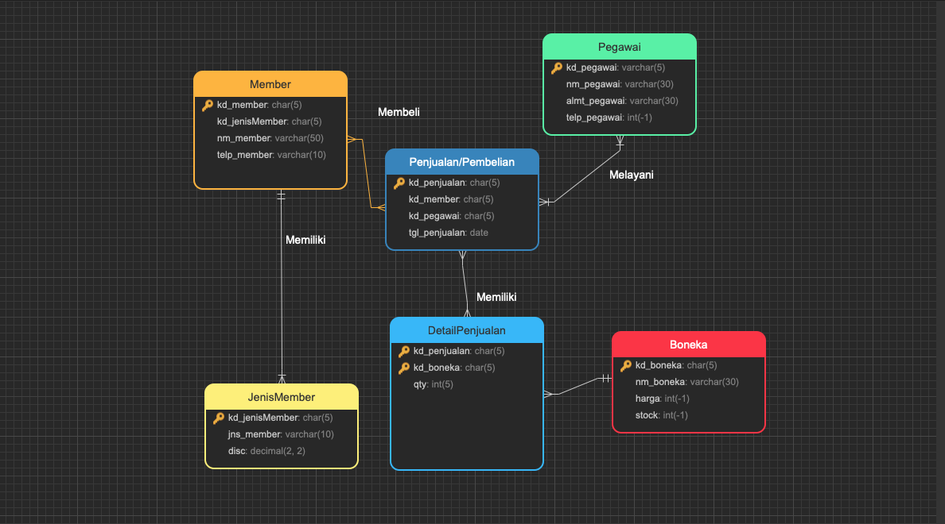

Tugas2

Konsumen

Primary Key : KdKonsumen

Foreign Key : Kd Konsumen

|  |  |  |  |
| --- | --- | --- | --- |
| Nama Field | Tipe data | Length | Keterangan |
| KdKonsumen | Char | 5 | Harus disi |
| NamaAwal | Varchar | 30 | Harus disi |
| NamaAkhir | Varchar | 30 |  |
| NoTelp | Integer |  |  |
| Email | Email | 30 |  |
| Keterangan | Keterangan | 30 |  |

Booking

Primary Key : KdBooking

Foreign Key : KdBooking

|  |  |  |  |
| --- | --- | --- | --- |
| Nama Field | Tipe data | Length | Keterangan |
| KdBooking | char | 5 | Harus disi |
| NoMeja | Integer | 30 |  |
| Tanggal | Date |  |  |

Meja

Primary Key : NoMeja

Foreign Key : NoMeja

|  |  |  |  |
| --- | --- | --- | --- |
| Nama Field | Tipe data | Length | Keterangan |
| NoMeja | char | 5 | Harus disi |
| DetailMeja | varchar | 30 |  |

Pesanan

Primary Key : KdPesanan

Foreign Key : KdPesanan

|  |  |  |  |
| --- | --- | --- | --- |
| Nama Field | Tipe data | Length | Keterangan |
| KdPesanan | Char | 5 | Harus disi |
| Tanggal | Date |  | Harus disi |

Staf

Primary Key : KdStaf

Foreign Key : KdStaf

|  |  |  |  |
| --- | --- | --- | --- |
| Nama Field | Tipe data | Length | Keterangan |
| KdStaf | Char | 5 | Harus disi |
| KdPeranan | Char | 5 | Harus disi |
| NamaAwal | Varchar | 30 |  |
| NamaAkhir | Varchar | 30 |  |

Peranan

Primary Key : KdPeranan

Foreign Key : KdPeranan

|  |  |  |  |
| --- | --- | --- | --- |
| Nama Field | Tipe data | Length | Keterangan |
| KdPeranan | Char | 5 | Harus disi |
| NamaPeranan | Varchar | 30 | Harus disi |

Menu Pesanan

Primary Key : KdMenuPesanan

Foreign Key : KdMenuPesanan

|  |  |  |  |
| --- | --- | --- | --- |
| Nama Field | Tipe data | Length | Keterangan |
| KdMenuPesanan | Char | 5 | Harus disi |
| Kuantitas | Varchar | 30 | Harus disi |
| Komen | Varchar | 50 |  |

Menu

Primary Key : KdMenuPesanan

Foreign Key : KdMenuPesanan

|  |  |  |  |
| --- | --- | --- | --- |
| Nama Field | Tipe data | Length | Keterangan |
| KdMenu | Char | 5 | Harus disi |
| Tanggal | Date | - | Harus disi |

Item Menu

Primary Key : KdItemMenu

Foreign Key : KdItemMenu

|  |  |  |  |
| --- | --- | --- | --- |
| Nama Field | Tipe data | Length | Keterangan |
| KdItemMenu | Char | 5 | Harus disi |
| Keterangan | Varchar | 30 |  |
| Harga | Integer | 30 | Harus disi |

Bahan

Primary Key : KdBahan

Foreign Key : KdBahan

|  |  |  |  |
| --- | --- | --- | --- |
| Nama Field | Tipe data | Length | Keterangan |
| KdBahan | Char | 5 | Harus disi |
| NamaBahan | Varchar | 30 | Harus disi |

Item Bahan

Primary Key : KdItemBahan

Foreign Key : KdItemBahan

|  |  |  |  |
| --- | --- | --- | --- |
| Nama Field | Tipe data | Length | Keterangan |
| KdItemBahan | Char | 5 | Harus disi |
| Kuantitas | Varchar | 30 | Harus disi |

Tipe Bahan

Primary Key :KdTipeBahan

Foreign Key : KdTipeBahan

|  |  |  |  |
| --- | --- | --- | --- |
| Nama Field | Tipe data | Length | Keterangan |
| KdTipeBahan | Char | 5 | Harus disi |
| deskripsi | Varchar | 30 | Harus disi |

CDM

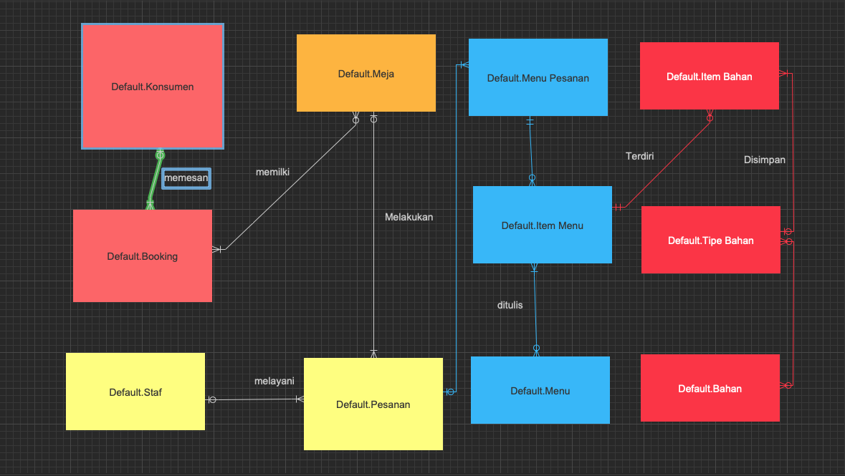

PDM

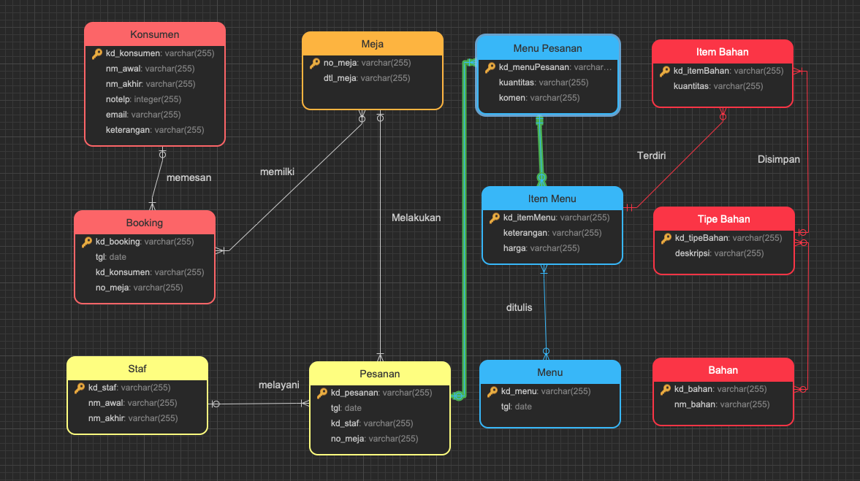

Tugas 3

Fasilitas

PrimaryKey : KdFasilitas

Foreign Key: KdFasilitas

|  |  |  |  |
| --- | --- | --- | --- |
| Nama Field | Tipe data | Length | Keterangan |
| KdFasilitas | Char | 5 | Harus diisi |
| NamaFasilitas | varchar | 30 |  |
| Lokasi | Varchar | 50 |  |

Member

PrimaryKey : KdFasilitas

Foreign Key: KdFasilitas

|  |  |  |  |
| --- | --- | --- | --- |
| Nama Field | Tipe data | Length | Keterangan |
| KdMember | Char | 5 | Harus diisi |
| NoIdentitas | char | 16 |  |
| NamaMember | Varchar | 30 |  |
| AlamatMember | Varchar | 50 |  |
| TelpMember | Varchar | 13 |  |

Pegawai

PrimaryKey : NIPPegawai

Foreign Key: NIPPegawai

|  |  |  |  |
| --- | --- | --- | --- |
| Nama Field | Tipe data | Length | Keterangan |
| NIPPegawai | Char | 18 | Harus Diisi |
| NamaPegawai | Varchar | 30 |  |
| AlamatPegawai | Varchar | 50 |  |
| TelpPegawai | varchar | 13 |  |

Transaksi

PrimaryKey : KdTransaksi

Foreign Key: KdTransaksi

|  |  |  |  |
| --- | --- | --- | --- |
| Nama Field | Tipe data | Length | Keterangan |
| KdTransaksi | Char | 5 |  |
| TglTransaksi | Date&Time | 5 |  |
| NominalTransaksi | Integer |  |  |
| DurasiPenyewaan | Time |  |  |

DosenKaryawan

PrimaryKey : NIPDK

Foreign Key:NIPDK

|  |  |  |  |
| --- | --- | --- | --- |
| Nama Field | Tipe data | Length | Keterangan |
| NIPDK | Char | 18 |  |
| NamaDK | Varchar | 30 |  |
| AlamatDK | Varchar | 50 |  |
| TelpDK | varchar | 13 |  |

Jurusan

PrimaryKey : KdJurusan

Foreign Key: KdJurusan

|  |  |  |  |
| --- | --- | --- | --- |
| Nama Field | Tipe data | Length | Keterangan |
| KdJurusan | char | 5 |  |
| NamaJurusan | varchar | 30 |  |

Prodi

PrimaryKey : KdProdi

Foreign Key: KdProdi

|  |  |  |  |
| --- | --- | --- | --- |
| Nama Field | Tipe data | Length | Keterangan |
| KdProdi | char | 5 |  |
| NamaProdi | varchar | 30 |  |

Fakultas

PrimaryKey : KdFakultas

Foreign Key: KdFakultas

|  |  |  |  |
| --- | --- | --- | --- |
| Nama Field | Tipe data | Length | Keterangan |
| KdFakultas | char | 5 |  |
| NamaFakultas | varchar | 30 |  |

Mahasiswa

PrimaryKey : NIM

Foreign Key: NIM

|  |  |  |  |
| --- | --- | --- | --- |
| Nama Field | Tipe data | Length | Keterangan |
| NIM | Char | 5 |  |
| NamaMahasiswa | Varchar | 30 |  |
| AlamatMahasiswa | Varchar | 50 |  |
| TelpMahasiswa | Varachar | 13 |  |

Melakukan

PrimaryKey : NIPDK,KdTransaksi,NIM

Foreign Key: NIPDK,KdTransaksi,NIM

|  |  |  |  |
| --- | --- | --- | --- |
| Nama Field | Tipe data | Length | Keterangan |
| NIPDK | Char | 18 |  |
| KdTransaksi | Char | 5 |  |
| NIM | Char | 5 |  |
| Diskon | Decimal | 5,5 |  |

CDM

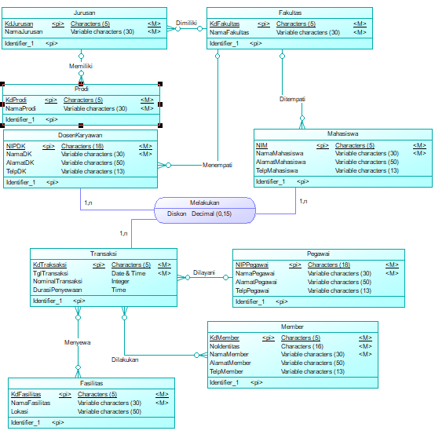

PDM

